
BPP Coursework Cover Sheet
Please use the table below as your cover sheet for the 1st page of the submission. The sheet should be before the cover/title page of your submission.

Programme | MSc Management with Data Analytics
Module name | Programming and Data Modelling
Student Reference Number (SRN)
Report/Assignment Title | Student Retention Analytics: Predicting Dropout Risk Through Machine Learning Techniques
Date of Submission
(Please attach the confirmation of any extension received)
Declaration of Original Work:
- I hereby declare that I have read and understood BPP’s regulations on plagiarism and that this is my original work, and that I have researched, undertaken, completed and submitted in accordance with the requirements of BPP School of Business.
- I declare that where I have used any AI tools, it was for the following reasons (highlight as appropriate):
  - To review a draft
  - To correct language errors
  - Other (please describe)
<You must remember to complete this AI declaration>
- I have copied & retained for BPP University’s reference all AI prompts used in the creation of AI content and all AI-generated responses in support of my assignment and attached relevant evidence in the appendices.
- I understand that I may be required to participate in a viva voce, where I will be questioned on any aspect of my assignment, including key concepts, theories, examples used, & any sources included.
Student Reference Number: ............................. Date: .......................
By submitting this coursework, you agree to all rules and regulations of BPP regarding assessments and awards for programmes. Please note, submission is your declaration you are fit to sit.
BPP University reserves the right to use all submitted work for educational purposes and may request that work be published for a wider audience.
BPP School of Business
The word count, excluding contents table, bibliography and appendices, is 4963 words.
Contents
1. Introduction And Problem Definition 6
1.1 Background And Context 6
1.2 Business Problem Definition 6
1.3 Project Aim And Objectives 6
1.4 Stakeholder Analysis 6
1.5 Business Impact And Organisational Benefits 7
1.6 Proposed Solution 7
1.7 Project Framework, Tools And Programming Approach 7
1.8 Report Structure 7
2. Data Collection, Data Preparation, And Ethics 8
2.1 Data Collection 9
2.2 Data Sources And Dataset Description 9
2.3 Etl Process 9
2.4 Data Cleaning And Preparation 10
2.5 Data Transformation And Feature Engineering 11
2.6 Training And Testing Dataset Creation 11
2.7 Ethical Considerations 11
2.8 Data Privacy, Fairness And Transparency 11
3. Analysis, Visualisation, And Modelling 12
3.1 Code Libraries And Analytical Tools 12
3.2 Exploratory Data Analysis 12
3.3 Model Selection And Justification 17
3.4 Logistic Regression Model 17
3.5 Random Forest Model 18
3.6 Model Evaluation And Comparison 18
3.7 Key Findings And Business Insights 19
3.8 Code Maintenance And Version Control 20
3.9 Deployment Considerations 20
4. Conclusion 20
5. Recommendations, Critical Evaluation, Reflection And Future Improvements 22
5.1 Recommendations 22
5.2 Automated Intervention Workflow 22
5.3 Leadership And Team Management Considerations 22
5.4 Gdpr And Responsible Ai Governance Framework 23
5.5 Critical Evaluation Of The Project 23
5.6 Personal Reflection 23
5.7 Future Improvements 24
References 25
Appendix: 27

List of Figures

Figure 1: Personal Dataset Sample(first 5 rows) 9
Figure 2: VLE Dataset Sample (first 5 rows) 9
Figure 3: Merged Dataset Overview 10
Figure 4: Gender Distribution 12
Figure 5: Ethnicity Distribution 13
Figure 6: Accommodation Type Distribution 13
Figure 7: Attendance Rate Distribution 13
Figure 8: Assignment Grade Distribution 14
Figure 9: Credits Passed Distribution 14
Figure 10: VLE Logins Distribution 14
Figure 11: Minutes on VLE Distribution 15
Figure 12: Dropout Risk vs Attendance Rate 15
Figure 13: Dropout Risk vs Assignment Grade 15
Figure 14: Dropout Risk vs Credits Passed 16
Figure 15: Correlation Heatmap 16
Figure 16: Logistic Regression Confusion Matrix 17
Figure 17: Random Forest Confusion Matrix 18
Figure 18: ROC Curve 18
Figure 19: Model Comparison Chart. 19
Figure 20: Feature Importance Chart 20

List of Tables

Table 1: Evaluation Metrics for Logistic Regression and Random Forest Classification Models 19
Table 2: Top Five Important Features 20

1. Introduction and Problem Definition

1.1 Background and Context
Student retention is a significant problem in the higher education industry because student withdrawals have negative consequences for students as well as universities. Students might face financial loss, career loss, and a lack of academic self-confidence, whereas universities are faced with funding issues, reputational problems, and even sustainability (Alkan et al., 2025). In recent years, due to the increase in the use of technology for educational purposes, there has been an explosion of data available from Virtual Learning Environments (VLEs), attendance records, and academic records. All of these make it possible to apply data analytics and machine learning techniques to discover patterns for student retention and dropouts (Lorenzo-Quiles et al., 2023).

1.2 Business Problem Definition
Most universities use manual processes to determine which students require assistance from the academic side, which is inefficient and may only happen once the student has underperformed due to the university’s delayed response. The databases used in the present analysis include demographic data, academic data, and data about interactions within the VLE, thus making it possible to create a predictive machine learning model based on the students’ risks.

1.3 Project Aim and Objectives
This project aims to develop and evaluate machine learning models capable of predicting student dropout risk using demographic, academic, and VLE engagement data.
The objectives of this project are:
- To integrate and prepare the provided datasets for analysis.
- To perform data cleaning, transformation, and validation procedures.
- To conduct exploratory data analysis (EDA) to identify key trends and relationships.
- To develop and compare two machine learning classification models.
- To evaluate model performance using appropriate metrics.
- To identify the most significant factors influencing dropout risk.
- To recommend the most suitable predictive model for deployment.

1.4 Stakeholder Analysis
Important stakeholders include students, learning support personnel, faculty members, module coordinators, the data analytics team, university management, and other governance organisations. Students benefit from early intervention, while the staff use their knowledge to offer help and improve retention. The compliance department ensures ethical use of data and adherence to GDPR guidelines, while student ambassadors help with issues of privacy and justice.

1.5 Business Impact and Organisational Benefits
An effective dropout prediction model will have many advantages for various stakeholders. The first benefit will accrue to the student as he will benefit from being flagged at an early stage of development. The student is then likely to get more assistance with his studies. Teachers and other stakeholders who help the student succeed can plan their work according to predictions made. The university administration can also benefit from better retention and planning. However, different parties will have differing stakes in this project, and care needs to be taken to balance these interests.

1.6 Proposed Solution
To solve the research problem, a machine learning algorithm-based approach was employed to design a prediction model of student dropouts. This system involves several steps, including data collection, data exploration, predictive analysis, and evaluation. Two types of classifiers were designed, namely Logistic Regression and Random Forest, which were then compared to identify which of them is better suited for the task. The selected model has the capability to be used for developing an early detection system for making decisions and taking action proactively. Based on experimental findings, the Random Forest classifier showed outstanding performance with 95% accuracy and a 0.984 ROC-AUC score.

1.7 Project Framework, Tools and Programming Approach
The study followed the CRISP-DM methodology that involves Business Understanding, Data Understanding, Data Preparation, Modelling, Evaluation, and Deployment steps (Caspari-Sadeghi, 2022). The decision to adopt this methodology was based on its well-structured nature, which facilitates alignment between the business needs and the analysis process. For the development of the code, Google Colab was used as the cloud computing platform, while Pandas, NumPy, Matplotlib, Seaborn, and Scikit-Learn were the libraries utilised.

1.8 Report Structure
The remaining sections in this report are presented in the following order: Section 2 is concerned with issues of data gathering, processing, and ethics. In Section 3, the topics include exploratory analysis of the data set, visualisation, and machine learning modelling. In Section 4, the conclusions drawn from the analyses are discussed.
1.9 Proposed Solution Design (Pseudocode)
The following pseudocode describes the whole process flow for the development of the student dropout prediction model. Pseudocode is platform-agnostic and gives a high-level understanding of the algorithm that has been designed in Python.
START
Load personal_data.xlsx
Load vle_data.csv
Merge datasets using the student ID
Check for missing values
Check for duplicate records
Clean and prepare the dataset
Encode categorical variables
Remove the ID column from the modelling features
Split the dataset into training and testing sets
Train Logistic Regression model
Evaluate the Logistic Regression model
Train Random Forest model
Evaluate the Random Forest model
Generate Confusion Matrices
Generate ROC Curve
Calculate Accuracy, Precision, Recall and F1 Score
Compare model performance
Identify important predictive features
Select the best-performing model
Generate recommendations for student intervention
END

2. Data Collection, Data Preparation, and Ethics

2.1 Data Collection
Two data sets were used in the process of data acquisition in this study. The first data set included information about the demographics of students and their academic achievements. The second data set consisted of information regarding virtual learning environment engagement (Yagcı, 2022). Both data sets gave a detailed insight into the characteristics, performance, and behaviour of the students (Johar et al., 2023). Data gathering in the study was carried out using the systems that are currently in use in the university, namely, information systems and virtual learning environments. Data obtained from multiple sources gave a more thorough analysis opportunity as it took into account not only academic but also behavioural data (Duro et al., 2026).

2.2 Data Sources and Dataset Description
Personal data, stored in personal_data.xlsx, consisted of 500 student records. Among the variables available were age, gender, ethnicity, first-generation student status, disability status, commuting time, living arrangements, receiving support from financial aid, attendance rate, grade of assignments submitted, credit hours passed, and the dropout risk. The second data file, named vle_data.csv, consisted of 500 records. It included information about various levels of interaction with the online learning environment, such as the number of logins per week, the the number of minutes spent, the number of pages visited, number of video lectures watched, activity in forums, number of quizzes attempted, number of late submissions made, and number of days since last visit to the virtual learning environment (Johar et al., 2023). Both datasets included an ID variable, which allowed for successful merging and the obtaining of a single dataset consisting of 500 observations and 21 variables. The target variable for this project was dropout_risk.
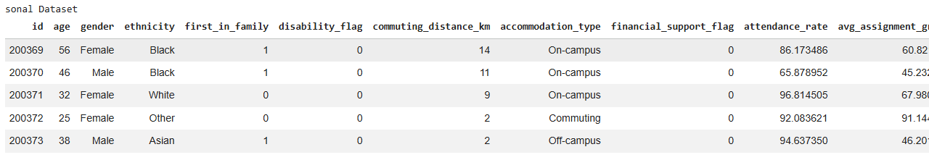
Figure 1: Personal Dataset Sample(first 5 rows)
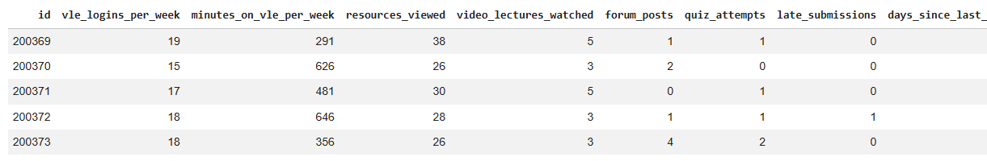
Figure 2: VLE Dataset Sample (first 5 rows)

2.3 ETL Process
Extract, Transform, and Load (ETL) methodology was used during the preparation phase. The extraction of data involved importing the data sets from Excel and CSV format into Python through the use of the Pandas module. Inspections on the data were done to ascertain the dimensions and format of the data set. During the transformation stage, the merging of data sets was done based on the common ID field. Inspections were performed to detect any missing values and duplicates (Guevara-Reyes et al., 2025). Descriptive statistics and functions for the data set details were used for this purpose. The categorical features, such as gender, ethnicity, whether students belong to the first generation, and accommodation type, were labelled through Label Encoding. This process is important since the machine learning algorithms demand numerical input values for the training of the model. In the load stage, a final dataset was developed through cleaning and can be used for exploring the data and making predictions.
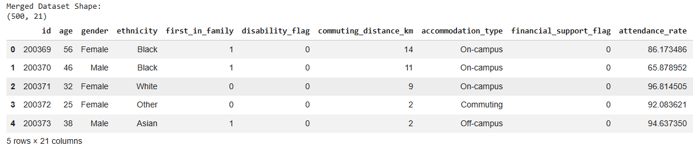
Figure 3: Merged Dataset Overview
Validation procedures were carried out after the transformation stage to ensure good-quality data. Distributions of the various variables were checked to make sure there were no outliers that could adversely affect the subsequent analysis of the data set combined. Verification of the type of data made sure that it is compatible with machine learning processes and other statistical techniques. The integration of demographic, academic and virtual learning environment (VLE) data resulted in the development of an integrated data set which gave a more comprehensive picture of students' behaviour and performance.

2.4 Data Cleaning and Preparation
Data cleaning is an essential phase of any data analytics project since any data errors could impact the effectiveness of the model. The datasets were assessed for missing values, duplicates, and inconsistent data. It was noted that there were no considerable amounts of missing data or duplicate entries, hence the limited amount of correction needed. The data sets were checked for data inconsistencies by means of descriptive statistics (Cho et al., 2023). Appropriate variable types were verified, and necessary conversions were made to facilitate machine learning modelling. Moreover, the ID predictor variable was excluded from the model training as it was simply used as an identification number and lacked predictive capabilities.

2.5 Data Transformation and Feature Engineering
The process of data transformation was carried out to maintain the compatibility of data with machine learning algorithms. Label Encoding technique was used on categorical variables in order to convert categories that were represented in the form of text to numeric format (Ayouni et al., 2021). Feature scaling was done with StandardScaler in the case of Logistic Regression to scale down the numeric variables to enhance performance. Minimal efforts were taken for feature engineering in order to avoid any kind of data bias.

2.6 Training and Testing Dataset Creation
The split between the training set and test set in the dataset was done using an 80:20 ratio. The training set was utilised to fit the machine learning models, whereas the test set was kept aside for validation purposes. To make sure that the target variable was represented uniformly in both the test and training sets, stratified sampling was carried out. This makes sure that the evaluation of the model performance is reliable and unbiased (Caspari-Sadeghi, 2022).

2.7 Ethical Considerations
The application of predictive analytics in the education sector poses various ethical concerns. Some of the information contained in the data set includes sensitive attributes like gender, ethnic background, whether or not the learner is disabled, and any financial assistance received (Bettahi et al., 2025). There is, therefore, a possibility of the model developed leading to some forms of biases that result in the learners being treated unfairly. Predictive analytics can help to benefit the learners but should never be used to disadvantage them. Automated decisions should never be allowed to determine how to handle the learners; there should always be some form of human supervision involved.

2.8 Data Privacy, Fairness and Transparency
Privacy of data is a key principle when it comes to dealing with information about students. Universities need to adhere to all relevant requirements regarding data protection, including GDPR. The data about students needs to be protected, accessed only by the appropriate people, and measures need to be taken during the analysis of the data as well. Another key principle that is necessary is transparency (Cho et al., 2023). The operations of predictive systems and predictions in making decisions should be clear to all interested parties, including the students. Fairness is another crucial component of the development and operation of the proposed prediction system. It is not meant to discriminate against certain individuals but to identify those who need help.
Furthermore, universities should have governance mechanisms in place to track the use of predictive models across their entire lifecycle. The model performance needs to be evaluated regularly to verify model efficiency, possible sources of model bias and ethical and legal requirements. Stakeholders need to be made aware of the process for prediction and the means by which outputs are used to aid decision-making (Guevara-Reyes et al., 2025). The continuous monitoring can help ensure the fairness, accountability and trust in the system. With robust data governance and clear communication, institutions can make sure that predictive analytics is applied responsibly to improve student success without infringing on the interests and rights of individuals.

3. Analysis, Visualisation, and Modelling

3.1 Code Libraries and Analytical Tools
The project has been carried out in Python on Google Colab. Data Preparation and merging were performed using pandas, and numerical analysis was performed using NumPy (Yağcı, 2022)—data visualisation techniques are included in Matplotlib and seaborn. The scikit-learn library was used to perform machine learning modelling, feature scaling and performance evaluations.

3.2 Exploratory Data Analysis
Exploratory Data Analysis (EDA) was performed to study the nature of the combined data and to observe the relationship between variables and the target variable, which was the dropout risk (Staneviciene et al., 2024). EDA is a crucial phase in the analytics life cycle due to its key role in gaining insight into the data and model-building decisions. The preliminary explorations were carried out on demographic attributes such as gender, ethnicity, and housing arrangements.
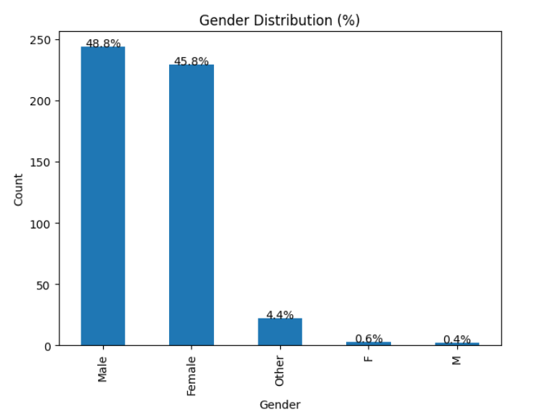
Figure 4: Gender Distribution
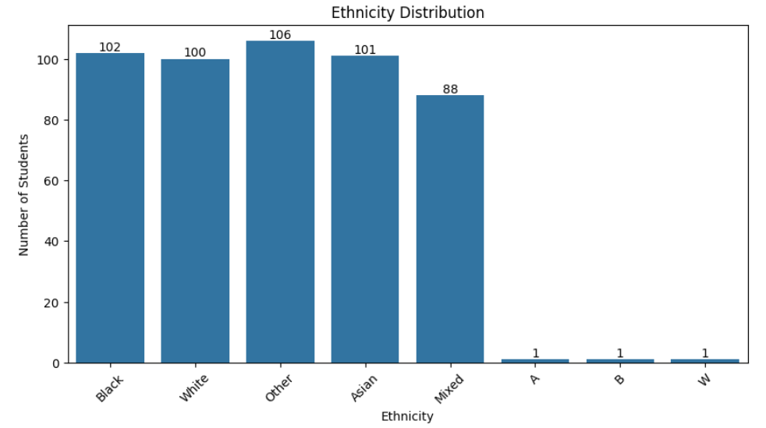
Figure 5: Ethnicity Distribution
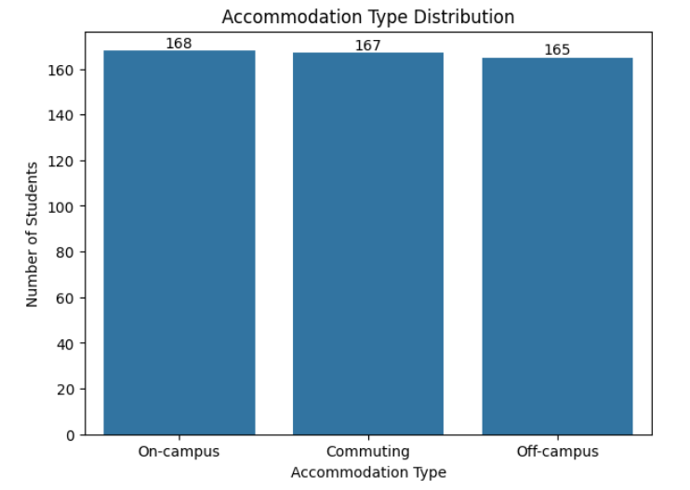
Figure 6: Accommodation Type Distribution
The analysis of academic variables such as attendance percentage, average score on assignments, and number of courses passed was performed using histograms and descriptive statistics. From the results obtained, there were discrepancies regarding academic achievement among the population of students, which could be linked to differences between at-risk and non-at-risk students.
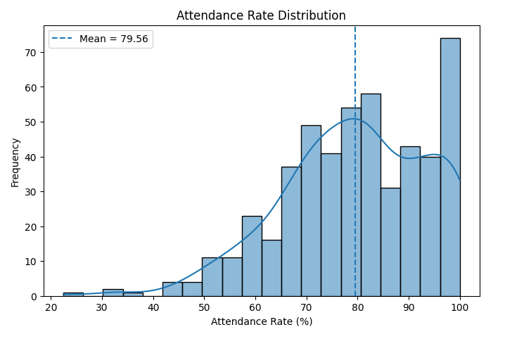
Figure 7: Attendance Rate Distribution
The attendance rate distribution demonstrates great diversity in the way that students take part in university activities. The higher this attribute value is, the more involved students will be. In terms of business, the attendance rate can serve as an alert indicator to Brownies University about problems that can occur with some students.
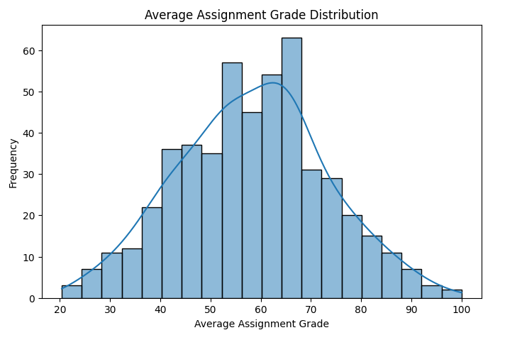
Figure 8: Assignment Grade Distribution
From the results, there is a need to provide students who score poorly on their assignments with more academic assistance, tutoring, and/or mentorship. In turn, this will help the institution retain more students since they will not drop out.
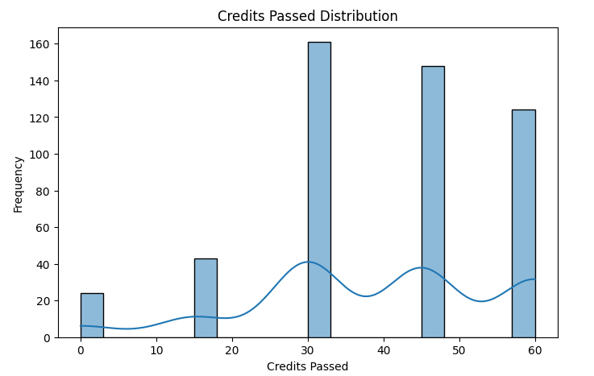
Figure 9: Credits Passed Distribution
The credit pass rate served as a measure of academic performance, with lower rates indicating increased probabilities of dropout (Staneviciene et al., 2024). Student engagement was measured through various metrics, including login frequency, time spent online, resource use, quiz participation, and activity in the last seven days. Reduced engagement indicated higher probabilities of dropout.
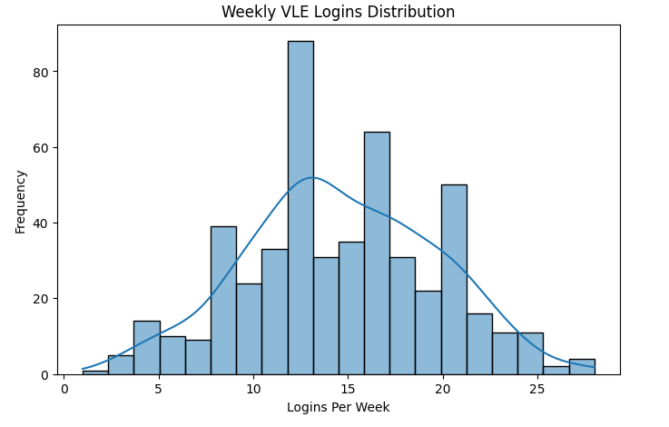
Figure 10: VLE Logins Distribution
This association between engagement in a VLE and the likelihood of dropping out suggests that participation in online learning is a reliable method of monitoring students. Those students who show little engagement in their online learning may be automatically identified for further follow-up.
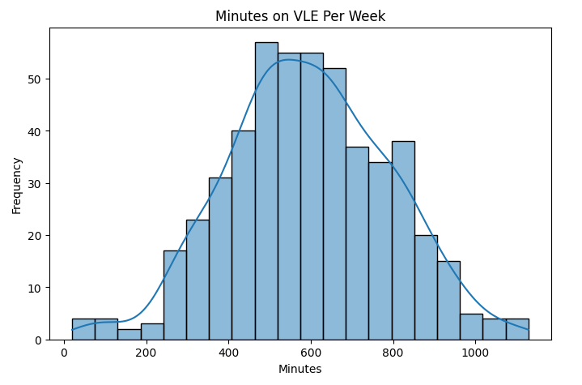
Figure 11: Minutes on VLE Distribution
According to the box plot analysis results, there were significant relationships between academic achievement and the likelihood of a student dropping out. The at-risk students had lower attendance rates, achieved lower grades on assignments, and had fewer passed credits than non-at-risk students. It means that academic achievement plays a major role in determining student dropout.
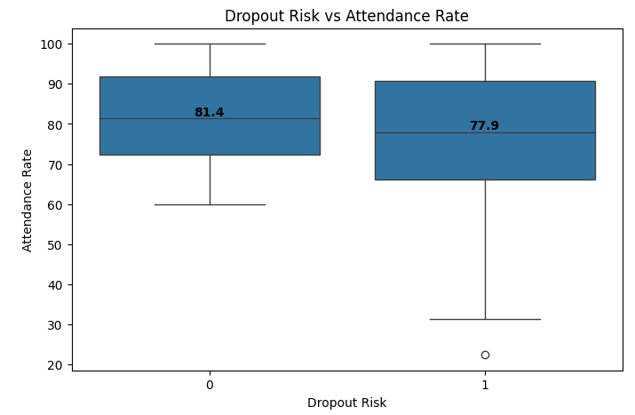
Figure 12: Dropout Risk vs Attendance Rate
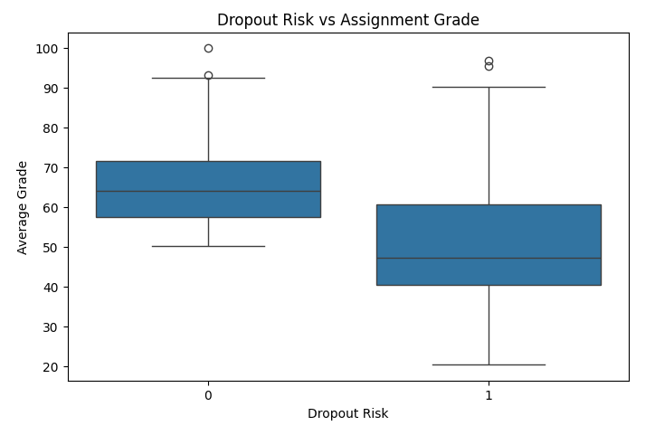
Figure 13: Dropout Risk vs Assignment Grade
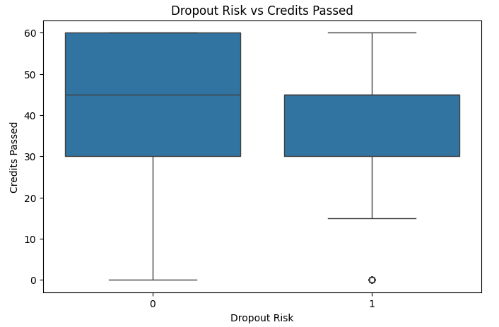
Figure 14: Dropout Risk vs Credits Passed
The box plots depicted in the figures are clearly indicative of differences between the at-risk group and the non-risk group. Students categorised as at risk usually tend to have lower attendance, poorer assignment grades, and less credit accumulation. This clearly illustrates the significance of such academic variables in assessing retention outcomes (Sole-Beteta et al., 2022). A correlation heatmap was created to test associations among different variables. It was discovered that the average assignment grade is negatively correlated with the risk of dropping out at the highest magnitude (-0.52). Similarly, there is a statistically significant negative relationship between attendance and risk of dropout.
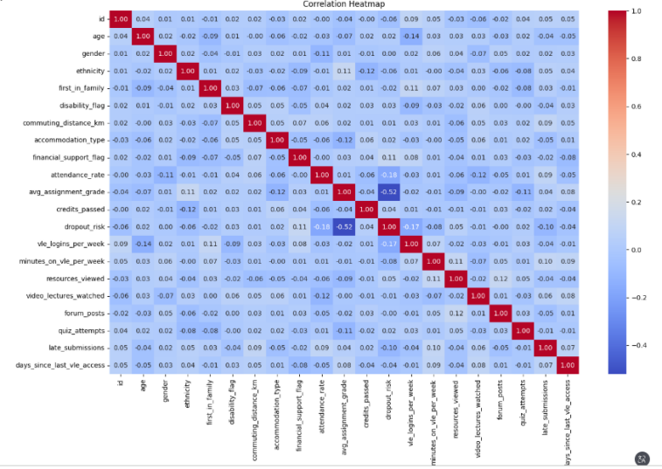
Figure 15: Correlation Heatmap
The correlation heatmap indicated that there were significant correlations between demographic, academic and engagement factors, and the risk of dropout. The average grade of assignments had the highest correlation with dropout risk, followed by attendance rate and log-in frequency of the virtual learning environment. The above results validated the choice of predictive features and machine learning models. From the EDA analysis, it was evident that academic performance and engagement behaviour were highly correlated with dropout risk (Matz et al., 2023).
3.2.1 EDA Validation Using Excel
To prove the consistency of the findings from the exploratory data analysis, it was decided to confirm them by making use of Microsoft Excel via pivot tables and descriptive statistics. In particular, the attendance levels, marks for assignments, and VLE engagement among students were checked according to their risk group for dropping out of the program. It turned out that the conclusions were consistent between the findings of the Python and Excel analyses (Meghji et al., 2023). Those students who belonged to the high-risk groups usually had worse performance in all areas considered.
3.2.2 Business Implications of EDA Findings
Through exploratory data analysis, it was evident that there is a significant association between dropout risk and such variables as attendance rate, assignment score, credits completed, and virtual learning environment usage. This research is important to Brownies University in that it provides a basis upon which the institution can measure the factors continually within the course of the academic year. This makes it easier to predict those students who are likely to drop out and ensure they receive the necessary attention before they actually withdraw from the school.

3.3 Model Selection and Justification
Logistic Regression and Random Forest have been chosen for the classification models. The reason behind choosing logistic regression is that it is an easy-to-understand baseline model that can be used to estimate the probability of dropping out and analyse the relationship between the variables (Matz et al., 2023). The random forest algorithm was chosen for its ability to handle non-linear relationships and avoid overfitting.

3.4 Logistic Regression Model
The logistic regression algorithm was taken as the base model, where the standardisation of data using StandardScaler was performed, followed by the division of data into train and test datasets in the ratio of 80%:20%. It achieved an accuracy score of 74%, while Precision, Recall, and F1 Score were all in the range of 72% (Romero & Liao, 2025).
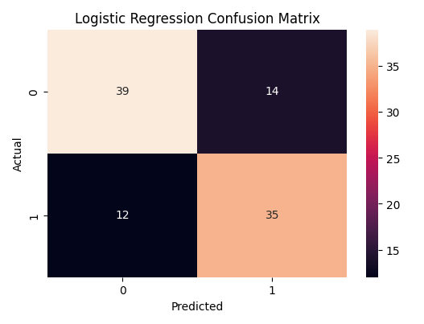
Figure 16: Logistic Regression Confusion Matrix

3.5 Random Forest Model
Another classification technique used is Random Forest. This classification algorithm was chosen because of its ability to analyse and learn from complex non-linear interactions among features without being dependent on rigid statistical assumptions. The model was applied using 200 decision trees, and it surpassed Logistic Regression considerably in its performance. It produced high accuracy of 95%, precision of 100%, recall of 89%, and F1-score of 94%. The confusion matrix showed that there were minimal mistakes made in classification. Moreover, the model gave us the ROC-AUC score of 0.984, which is very impressive.
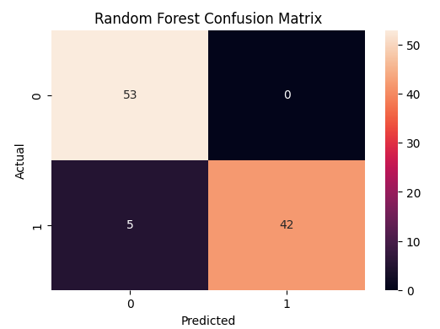
Figure 17: Random Forest Confusion Matrix
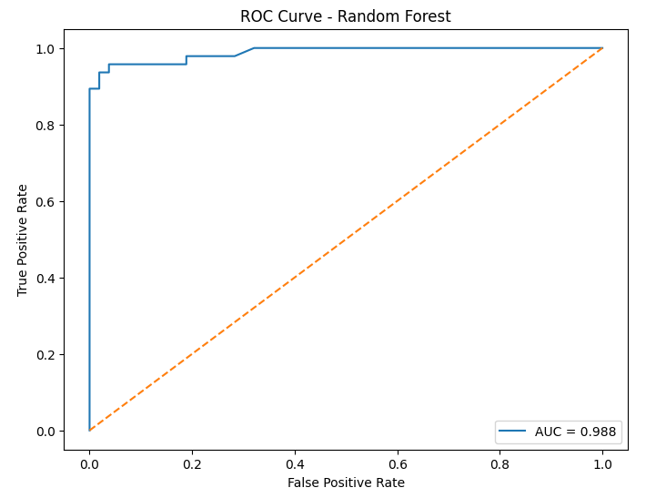
Figure 18: ROC Curve

3.6 Model Evaluation and Comparison
Performance of the model was assessed based on Accuracy, Precision, Recall, F1 Score, and ROC-AUC values. All the mentioned metrics provide a thorough evaluation of classification efficiency and make model comparison objective.
Table 1: Evaluation Metrics for Logistic Regression and Random Forest Classification Models
Metric | Logistic Regression | Random Forest
Accuracy | 74% | 95%
Precision | 72% | 100%
Recall | 72% | 89%
F1 Score | 72% | 94%
ROC-AUC | 0.79 | 0.984
The ROC-AUC measurement also further proves the superiority of the Random Forest method. The two models were compared based on accuracy, precision, recall, F1-score, and ROC-AUC measurements. While the Logistic Regression provided satisfactory prediction results and understanding, Random Forest performed better in classifying the risks between the two groups due to its ability to model complex relationships, scoring an ROC-AUC of 0.984.
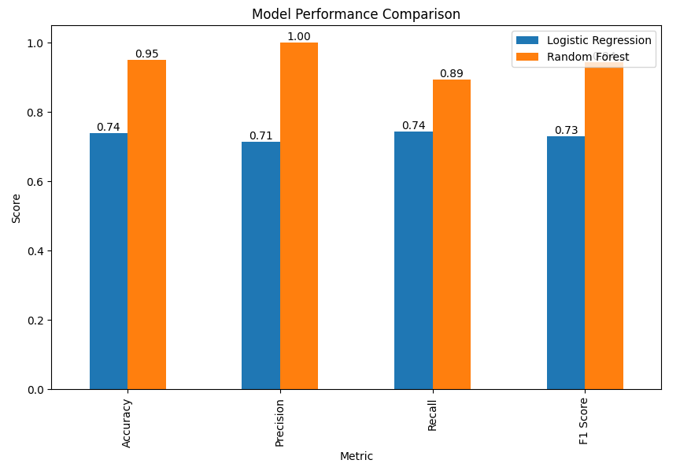
Figure 19: Model Comparison Chart.

3.7 Key Findings and Business Insights
From the feature importance analysis, it was established that the most important variable for predicting whether a learner is at risk is the average grade on assignments, followed by attendance and number of logins on the virtual learning environment (Meghji et al., 2023). The results imply that performance in class and engagement play a significant role in determining whether learners will continue their studies or not. Learners who perform poorly academically, have poor attendance, and do not log in frequently to the virtual learning environment are at high risk of dropping out. This study can offer guidance to university management when making decisions about retention programs.
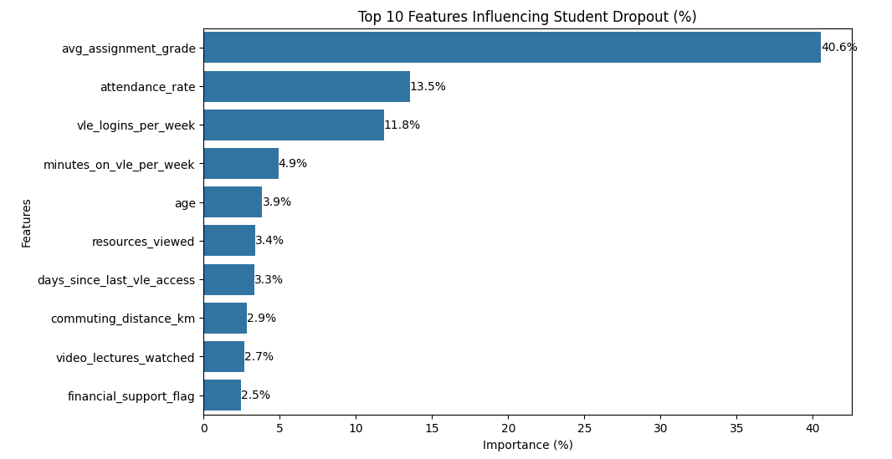
Figure 20: Feature Importance Chart
Table 2: Top Five Important Features
Rank | Feature | Importance
1 | avg_assignment_grade | 0.401
2 | attendance_rate | 0.136
3 | vle_logins_per_week | 0.111
4 | minutes_on_vle_per_week | 0.047
5 | days_since_last_vle_access | 0.033

3.8 Code Maintenance and Version Control
For maintainability, the code should follow modular programming principles with reusable functions for data preparation, model training, and evaluation. Code reviews, pull requests, and branching strategies help manage changes safely. Comprehensive documentation, including comments and user guides, supports future development, improves collaboration, and ensures the long-term sustainability of the predictive analytics solution.

3.9 Deployment Considerations
Post-deployment, the system must include dashboard-driven monitoring along with alert generation for students at risk. In situations where the risks are high, human intervention must be carried out prior to any action being taken. Student Services must then organise the necessary interventions. The system will have to be monitored regularly, with retraining done on occasion.

4. Conclusion
The main objective of this project was to build and validate machine learning models able to predict the likelihood of students dropping out based on demographic, academic, and VLE usage features. The project succeeded in bringing together two datasets related to the relevant information about the students and their learning activities in order to perform an overall study of retention drivers. An analysis methodology based on CRISP-DM was applied to guide the entire project implementation. Two datasets were gathered, cleansed, and processed using an ETL approach, and Exploratory Data Analysis (EDA) techniques were used to study their distribution, correlations, and possible drivers of dropout risk.
Logistic Regression and Random Forest were two classification models that were created. In particular, Logistic Regression was used as the base model and obtained around 74% accuracy, thereby having reasonable prediction capabilities. Nonetheless, the Random Forest model demonstrated much better results compared to Logistic Regression in all metrics used. The accuracy of Random Forest reached about 95%, precision of 100%, recall of 89%, F1 score of 94%, and ROC-AUC value of 0.984. Thus, we can claim that a highly efficient model for predicting which students have a high dropout probability and who do not.
The result of this project has shown that predictive analytics can be useful to support student retention strategies in universities. The early detection of students who might be at risk of dropping out of the university gives time for action to be taken before complications get to an advanced stage. The Random Forest model has performed well, and machine learning methods can be used to assist in evidence-based decision-making and the use of student support resources more effectively. Additionally, demographic, academic, and engagement-related data give a comprehensive picture of student engagement, which allows institutions to gain a deeper understanding of the factors that relate to a student's chances of retention and academic success.
The feature importance analysis has further confirmed that the mean assignment score is the strongest predictor of student attrition risk, followed by the attendance rate and the frequency of logins to the virtual learning environment. This shows that academic performance and student engagement are crucial when it comes to making predictions about student retention. This project proves that machine learning is an effective way to achieve practical assistance in the early identification of at-risk students. Universities will be able to implement proactive measures, increase the effectiveness of student support programs and save money in the process. This research also brings up the aspect of ethics, such as confidentiality, equity, transparency and responsible usage of the information during the whole analysis process. In general, this project accomplished all set goals and revealed Random Forest as the best solution for implementation. The results of the project have a number of implications and could be useful for other educational establishments using big data technology in their work.

5. Recommendations, Critical Evaluation, Reflection and Future Improvements

5.1 Recommendations
The Random Forest model is the best predictive model, with an accuracy of 95% and an ROC-AUC score of 0.984; thus, it should be implemented as the preferred model at Brownies University. An early warning system is needed to ensure students are identified with low assignment grades, low attendance and low levels of engagement on the VLE to allow early intervention from academic advisers and support teams. Academic mentoring, monitoring attendance, study skills workshops and wellbeing provision should be offered to pupils identified as at risk of failure. Further, the system should be regularly retrained with new student data to keep the accuracy and relevance of the prediction up to date. Staff should be trained to interpret predictions and use them correctly. Lastly, all predictions should occur in a context that fosters fairness, transparency, responsible decision-making and adherence to GDPR requirements.

5.2 Automated Intervention Workflow
To ensure the best possible effect of the predictive analytics solution, Brownies University should incorporate the Random Forest model into an automated student support process. Student information can be analysed regularly to detect pupils at risk of withdrawing. Those students who qualify for 'high-risk' can then be flagged automatically, and academic advisors and support staff can be notified. Specific interventions, e.g., mentoring, attendance monitoring, counselling and study supports, can be offered according to identified needs. Ongoing monitoring and periodic model updates will enable intervention effectiveness to be assessed, and retention outcomes will be increased. This proactive strategy will help the university aid students before withdrawal because of academic challenges.

5.3 Leadership and Team Management Considerations
Implementing a student dropout prediction system necessitates effective leadership, collaboration, and communication among data analysts, developers, academic staff, and the university management. The Project leader needs to maintain a strong focus on objectives, the management of resources, and the institutional agendas through regular consultations with stakeholders and monitoring of progress. One of the difficulties is aligning the interests of technical and non-technical stakeholders, since developers are interested in the performance of their models while academic staff members are more interested in what their students have achieved. Successful leadership helps to interpret technical findings into practical information. Additionally, staff training is crucial to make sure that the predictions are understood and utilised appropriately. Effective partnership efforts and ongoing learning will ensure the successful implementation and sustained use of the system.

5.4 GDPR and Responsible AI Governance Framework
A student dropout prediction system must be geared towards GDPR principles and responsible AI practices. Student data should only be gathered and used for the purposes of education and should be given access to only those entitled to it. Only relevant data should be used for the predictive model, following the data minimisation principles. Human oversight should always be a part of the decision-making process. The model predictions should complement and not supplant the professional judgment of academic advisors and student support teams. It will also be important to teach students about the use of their data and how the use of predictive analytics helps retention efforts. To ensure equitable performance across student groups, regular monitoring and evaluation of model performance should be performed to look for potential bias. It is important that periodic review and model retraining should also be done to keep the accuracy and transparency. GDPR compliance, ethical governance, and human oversight can work together to ensure the responsible and ethical use of predictive analytics in the best interest of Brownies University students.

5.5 Critical Evaluation of the Project
While Logistic Regression was interpreted and Random Forest was more predictive, there was a trade-off between the two. Logistic Regression yields a smaller and more understandable model and helps teachers more easily grasp how the model's predictions are made. The Random Forest, by comparison, is a more complex ensemble model that may decrease the transparency but is more powerful in its predictive ability. Thus, although it is recommended to deploy Random Forest algorithms, the universities should make sure that the model outputs come with clear explanations and human supervision to facilitate the informed decision-making process.

5.6 Personal Reflection
Through this project, I received practical experience in implementing different data analytics and machine learning approaches to address a particular problem situation. During this project, much insight has been acquired on a variety of issues, including data pre-processing, exploratory data analysis, predictive modelling, and evaluating models. It has been realised that data quality and pre-processing play an extremely important role in all processes of machine learning. Such processes as data integration, validation, transformation, and preparation have been required for generating meaningful analytic outcomes. In addition, through the completion of this task, it has been learned the importance of achieving a balance between technical and ethical issues when developing a model. When creating models that can predict outcomes, one should pay attention to such factors as privacy concerns, moral issues, transparency, and the requirements of different stakeholders. This information will be very helpful for my future practice in the sphere of data analysis and artificial intelligence.

5.7 Future Improvements
There are several ways that will make this system even better at predicting the outcomes for students. Firstly, a much bigger database consisting of data on students from different years or universities will help to ensure the generalisability of the models. Secondly, additional factors like student mental health, previous experience with counselling services, the financial situation of the student, and any other feedback data will help to provide a better understanding of their chances of dropping out. Moreover, such techniques as boosting algorithms like XGBoost, LightGBM, and neural networks could be used to see if there is a way to get better results. Finally, an interactive dashboard combined with a predictive algorithm will allow for monitoring of students and notifying academic advisors about the problem.

References
Abdelkarim Bettahi, Fatima-Zahra Belouadha and Hamid Harroud (2025). A Modular and Explainable Machine Learning Pipeline for Student Dropout Prediction in Higher Education. Algorithms, 18(10), pp.662–662. doi: https://doi.org/10.3390/a18100662.
Alkan, B.B., Serafettin Kuzucuk, Alkan, N. and Sinan, A. (2025). Using machine learning to predict student outcomes for early intervention and formative assessment. Scientific Reports, [online] 15(1). doi: https://doi.org/10.1038/s41598-025-23409-w.
Ayouni, S., Hajjej, F., Maddeh, M. and Al-Otaibi, S. (2021). A new ML-based approach to enhance student engagement in an online environment. PLOS ONE, 16(11), p.e0258788. doi: https://doi.org/10.1371/journal.pone.0258788.
Caspari-Sadeghi, S. (2022). Applying Learning Analytics in Online Environments: Measuring Learners’ Engagement Unobtrusively. Frontiers in Education, 7. doi:https://doi.org/10.3389/feduc.2022.840947.
Cho, C.-H., Yu, Y. and Hyeon Gyu Kim (2023). A Study on Dropout Prediction for University Students Using Machine Learning. Applied Sciences, 13(21), pp.12004–12004. doi: https://doi.org/10.3390/app132112004.
Duro, B., Gomes, A., Correia, F.B., Borges, A.R. and Bernardino, J. (2026). Machine Learning and Deep Learning for Dropout Prediction in Higher Education: A Review. Computers, 15(3), p.164. doi: https://doi.org/10.3390/computers15030164.
Guevara-Reyes, R., Iván Ortiz-Garcés, Andrade, R., Cox-Riquetti, F. and Villegas-Ch, W. (2025). Machine learning models for academic performance prediction: interpretability and application in educational decision-making. Frontiers in Education, 10. doi: https://doi.org/10.3389/feduc.2025.1632315.
Johar, N.A., Kew, S.N., Tasir, Z. and Koh, E. (2023). Learning analytics on student engagement to enhance students’ learning performance: A systematic review. Sustainability, [online] 15(10), p.7849. doi: https://doi.org/10.3390/su15107849.
Lorenzo-Quiles, O., Galdón-López, S. and Lendínez-Turón, A. (2023). Dropout at university. Variables involved on it. Frontiers in Education, 8. doi: https://doi.org/10.3389/feduc.2023.1159864.
Matz, S.C., Bukow, C.S., Peters, H., Deacons, C. and Stachl, C. (2023). Using machine learning to predict student retention from socio-demographic characteristics and app-based engagement metrics. Scientific Reports, [online] 13(1), p.5705. doi: https://doi.org/10.1038/s41598-023-32484-w.
Meghji, A.F., Naeem Ahmed Mahoto, Yousef Asiri, Hani Alshahrani, Sulaiman, A. and Shaikh, A. (2023). Early detection of student degree-level academic performance using educational data mining. PeerJ, 9, pp.e1294–e1294. doi: https://doi.org/10.7717/peerj-cs.1294.
Romero, S. and Liao, X. (2025). Statistical and machine learning models for predicting university dropout and scholarship impact. PLOS One, 20(6), p.e0325047. doi: https://doi.org/10.1371/journal.pone.0325047.
Solé-Beteta, X., Navarro, J., Gajšek, B., Guadagni, A. and Zaballos, A. (2022). A Data-Driven Approach to Quantify and Measure Students’ Engagement in Synchronous Virtual Learning Environments. Sensors, 22(9), p.3294. doi: https://doi.org/10.3390/s22093294.
Staneviciene, E., Gudoniene, D., Vytenis Punys and Arturas Kukstys (2024). A Case Study on the Data Mining-Based Prediction of Students’ Performance for Effective and Sustainable E-Learning. Sustainability, 16(23), pp.10442–10442. doi: https://doi.org/10.3390/su162310442.
Yağcı, M. (2022). Educational data mining: prediction of students’ academic performance using machine learning algorithms. Smart Learning Environments, [online] 9(1). doi: https://doi.org/10.1186/s40561-022-00192-z.

Appendix:
